2020-21 Geography Curriculum Area Action Plan
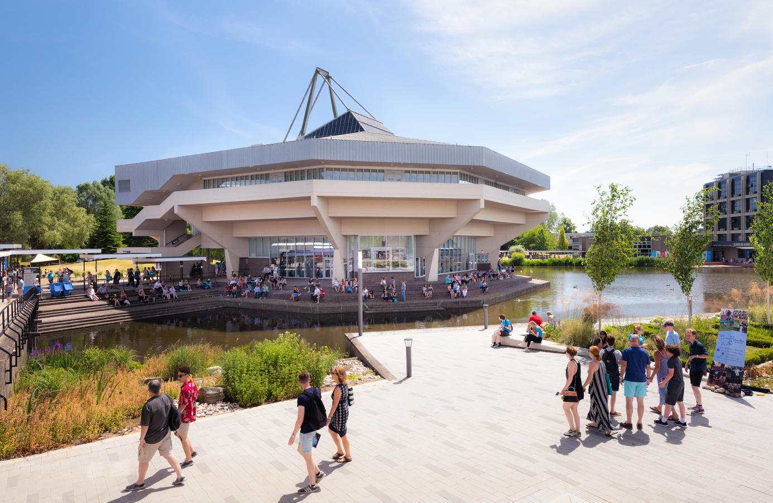

11-16 PGCE
(with Post-16 Enhancement)

Geography PGCE Action Plan 2020-21

Target 1: To review the success of CA sessions, whilst ensuring there is clear planning documentation which links to the CCF
Actions to achieve targets | Link to Standards/  Requirements | Timescale/ staging points | Staff responsible | Resource implications | Review date/s | Monitoring | Evaluation and success criteria
- Use of google forms after each period of CA input to gather feedback from trainees  - Amend CA sessions based on trainee feedback  - Creation of planning documentation which tracks and formalises the CA session links with CCF | Link to CCF and all TS | Trainee feedback forms to be completed by  - Mid Nov 20  - End Feb 21  - End June 21 | GR | Time  Opportunity to share ideas with other CA lead tutors | Jan 21  April 21  July 21 | CBS | CBS  External examiner report  - Feedback from trainees is significantly positive  - Actions taken to address any identified areas for improvement  - Existence of coherent planning documentation which tracks and formalises the CA sessions links with the CCF  - External examiner report is significantly positive

Success Criteria:
- Feedback from trainees is significantly positive
- Actions taken to address any identified areas for improvement
- Existence of coherent planning documentation which tracks and formalises the CA sessions links with the CCF
- External examiner report is significantly positive

Target 2: To establish a group of geography mentors, who feel supported and well-informed regarding the partnership between trainee, school and university, as well as the CCF
Actions to achieve targets | Link to Standards/  Requirements | Timescale/ staging points | Staff responsible | Resource implications | Review date/s | Monitoring | Evaluation and success criteria
- Fortnightly (minimum) collective communication/ updates with mentor team, outlining suggested activities to ensure delivery of the CCF requirements  - Fortnightly (minimum) communication/ update with trainees to ensure consistency of messages between schools, trainee and university  - Regular mentor surgery drop-ins  - Gather feedback from mentors  - Actions are taken to address feedback from mentors  - Creation of a designated geography mentor support area on UoY website, with subject specific exemplar material | Link to CCF and all TS | Mentor feedback forms to be completed at the end of each block  - End Dec 2020  - End Feb 2021  - End April 2021  - End June 2021 | GR | Time  Discussion with other CA lead tutors to share ideas | Jan 21  April 21  July 21 | CBS | CBS  External examiner report  - Feedback from mentors (and trainees) is significantly positive, with mentors having a clear understanding of the requirements/ their role in delivering the CCF  - Actions taken to address any identified areas for improvement from mentors  - Existence of coherent planning documentation which tracks and formalises the communication with and actions of mentors and links with the CCF  - Existence of a designated geography mentor support area on UoY website  - External examiner report is significantly positive

Success Criteria:
- Feedback from mentors (and trainees) is significantly positive, with mentors having a clear understanding of the requirements/ their role in delivering the CCF
- Actions taken to address any identified areas for improvement from mentors
- Existence of coherent planning documentation which tracks and formalises the communication with and actions of mentors and links with the CCF
- Existence of a designated geography mentor support area on UoY website
- External examiner report is significantly positive

Target 3: Creation of an alternative training programme for those trainees who are not placed in schools due to impacts/ restrictions from C19
Actions to achieve targets | Link to Standards/  Requirements | Timescale/ staging points | Staff responsible | Resource implications | Review date/s | Monitoring | Evaluation and success criteria
- Feedback from unplaced trainees to identify bespoke areas of concern/ interest  - Creation of CA programme (1) -which looks to further develop the trainees’ skills and preparedness for schools through a developmental phase  - Creation of CA programme (2) -which looks to further develop the trainees’ skills and preparedness for schools through a refining phase  - Use of google forms after each period of alternative CA provision to gather feedback from trainees | All TS but esp. TS3, TS4 and TS5 | Alternative provision is updated weekly  Trainee feedback forms to be completed by  - End Dec 20  - End Feb 21  - End April 21  - End June 21 | GR | Time  GA institutional membership in order to access additional quality CPD (already agreed)  Opportunity to share ideas with other CA lead tutors | Jan 21  April 21  July 21 | CBS | CBS  External examiner report  - Existence of alternative training programme (see VLE)  - Feedback from unplaced trainee is significantly positive  - Actions taken to address any identified areas for improvement from trainees  - External examiner report is significantly positive

Success Criteria:
- Existence of alternative training programme (see VLE)
- Feedback from unplaced trainee is significantly positive
- Actions taken to address any identified areas for improvement from trainees
- External examiner report is significantly positive

Target 4: To build a designated geography resource/ workspace for trainees to utilise, in addition to library resources that are specific to the geography PGCE
Actions to achieve targets | Link to Standards/  Requirements | Timescale/ staging points | Staff responsible | Resource implications | Review date/s | Monitoring | Evaluation and success criteria
- Allocated space for geography trainees to use/ access resources  - Procurement of a range of resources to support trainee development  - Organisation of resources to ensure relevant materials can be easily found  - Liaise with library with regards to required course materials | All TS but especially the preamble | Procurement of resources is ongoing throughout the year but physical setting up of space is likely to be in summer term due to C19 restrictions on campus at present | GR | Time  GA institutional membership in order to access resources (already agreed)  Budget for additional library purchases (all requests have been granted so far) | July 21 | CBS | CBS  - Allocated space for geography trainees to use/ access resources  - A range of resources to support trainee development

Success Criteria:
- Allocated space for geography trainees to use/ access resources
- A range of resources to support trainee development

